Software Requirements Specifications

CitrusInsight AI

Project Code:

Internal Advisor: Dr. Fahad Maqbool

Project Manager: Dr. Saad Razzaq

Project Team:

Muhammad Abdullah (BSCS51F21S015)
Hawaris Toheed (BSCS51F21S036)
Muhammad Saqlain Mushtaq (BSCS51F21S011)

Submission Date: 16-05-2025

_____________________
Project Manager’s Signature
Document Information

Category | Information
Customer | CS & IT, UOS
Project | CitrusInsight AI
Document | Requirement Specifications
Document Version | 1.0
Identifier | PGBH01-2020-RS
Status | Draft
Author(s) | Muhammad Abdullah, M Saqlain Mushtaq, Hawaris Toheed
Approver(s) | PM
Issue Date | May. 16, 2025
Document Location
Distribution | - Advisor  - PM  - Project Office

Definition of Terms, Acronyms and Abbreviations

This section should provide the definitions of all terms, acronyms, and abbreviations required to interpret the terms used in the document properly.

Term | Description
ASP | Active Server Pages
RS | Requirements Specifications

Table of Contents
1. Introduction 4
1.1 Purpose of Document 4
1.2 Project Overview 4
1.3 Scope 4
2. Overall System Description 5
2.1 User characteristics 5
2.2 Operating environment 5
2.3 System constraints 6
3. External Interface Requirements 7
3.1 Hardware Interfaces 7
3.2 Software Interfaces 7
3.3 Communications Interfaces 7
4. Functional Requirements 8
5. Non-functional Requirements 8
5.1 Performance Requirements 8
5.2 Safety Requirements 9
5.3 Security Requirements 9
5.4 User Documentation 9
6. Assumptions and Dependencies 9
7. System Architecture 10
8. Use Cases 13
8.1 Use Case Diagrams 13
8.2 Use Case Description 13
9. Graphical User Interfaces 18
10. High Level Design 25
10.1 ER Diagram 26
10.2 Data Dictionary 26
10.2.1 Data 1 26
10.2.2 Data 2 27
10.2.3 Data n 27
11. Requirements Traceability Matrix 29
12. Risk Analysis 29
13. Cost Estimation Sheet 30
14. References 31

Introduction

  - Purpose of Document
The objective of this document is to describe the specifications of CitrusInsight AI project, such as its goals, scope, software requirements, hardware requirements, Constraints, functionalities and projected outcomes. The report presents a detailed explanation of how the system will help citrus farmers by providing timely suggestions, disease identification, and cost savings for orchard management. The targeted audience for this document includes project supervisor, Project evaluator and developers. This document ensures a shared understanding among all parties involved, preventing miscommunication and aiding in the smooth development and deployment of the system. It specifies both functional and non-functional requirements, acting as a reference for developers while also setting key constraints such as technical, hardware, environmental, and cultural limitations.

  - Project Overview
Citrus farming is a vital sector in agriculture, but in recent years millions of dollars of Citrus production lost due to various disease in citrus plants and farmer does not have enough knowledge about diseases and their solutions also farmers often face significant challenges in maximizing yield and maintaining high-quality produce due to a lack of timely, reliable guidance. Currently, there is no comprehensive platform that provides farmers with month-wise recommendations for fertilizer, pesticide use, irrigation schedules, or disease management based on real-time data. Despite some progress in agricultural technology, there remains a gap in integrating all necessary tools into one accessible system for farmers.
Our project CitrusInsight AI aims to address these gaps by creating an integrated citrus recommendation system that not only provides guidance on irrigation, fertilizers, and pesticides, but also incorporates disease detection through machine learning algorithms using citrus leaf datasets. Additionally, the system will allow farmers to receive customized plans for establishing new citrus orchards, including land preparation, planting density.
By providing a user-friendly platform that delivers data-driven recommendations, this system will empower farmers to enhance the quality of their produce, ensure compliance with international export standards, and improve overall farm profitability. To verify the proposal, we will gather feedback from citrus farming experts, pilot test the system with real farmers, and validate the system’s predictions against actual farm data. This project has the potential to transform citrus farming practices, boost the local economy, and promote sustainable agricultural growth.

  - Scope
The scope of the project includes the following:

What the system will do:
- Provide month-wise recommendations for irrigation, fertilizer application, and pesticide use.
- Use machine learning algorithms to detect citrus leaf diseases.
- Offer cost estimations for land preparation and plantation density.
- Improve adherence to international citrus export standards.

What the system will not do:
- The system will not physically implement the recommendations; it only provides guidance.
- It will not cover crops outside of citrus farming.
- The project will not include real-time soil moisture monitoring or weather prediction, relying instead on historical and pre-collected data.

Overall System Description
This section describes the environment in which the Citrus Recommendation System will be developed and used, identifies the intended users, and outlines the known constraints, assumptions, and dependencies.

  - User characteristics
The system will cater to multiple user classes, categorized as follows:
- Primary Users:
- Citrus Farmers: The main beneficiaries who will use the system for guidance on irrigation, fertilizers, pesticides, and disease detection. They may have limited technical knowledge, so the interface must be user-friendly.
- Agricultural Experts: These users will verify the recommendations and provide insights for refining the system.

- Secondary Users:
- Agricultural Researchers: May use the system’s data for studies on precision farming.
- Government and Export Authorities: Can utilize the platform for ensuring compliance with citrus export standards.
- Developers and System Administrators: Responsible for maintaining and updating the system.

  - Operating environment
The Citrus Recommendation System will function in an environment that supports both web and mobile access. The expected operating environment includes:
- Hardware Platform:
The hardware specifications required to run the system smoothly are:
- Processor: Intel Core 2 Duo (or equivalent AMD) [Core i3+ recommended for better performance]
- RAM: Minimum 2GB (4GB recommended for better performance)
- Hard Disk Space: Minimum 500MB free space (for the website + additional space for logs, temporary files, database storage and Xampp server)
- Network: Stable internet connection (for remote access of model API and image uploading and calling the model API).
- Operating System:
CitrusInsight AI can be operate on any of these following operating system:
- Windows: Windows XP, Windows 7, Windows 8, Windows 10, Windows 11 (64-bit recommended for better performance)
- Linux: Ubuntu 18.04+ (or any distribution supporting XAMPP)
- MacOS: macOS Catalina or later (MAMP required for PHP & MySQL support).
- Software Requirements:
The software components required to develop and run the system are:
- Web Server: XAMPP (Apache, MySQL, PHP, and phpMyAdmin)
- Programming Languages:
  - Frontend: HTML5, CSS, JavaScript
  - Backend: PHP
- Database Management System (DBMS): MySQL (via XAMPP)
- Development Environment: VS Code (or any preferred code editor) and Jupiter Notebook.
- Browser Compatibility: Google Chrome, Mozilla Firefox, Microsoft Edge (latest versions recommended).

  - System constraints
The following constraints may impact the system’s development and operation:
Software constraints
The model is hosted on Hugging Face, meaning it relies on Hugging Face's uptime, response time, and API limitations. The front-end is restricted to HTML, CSS, and JavaScript, while the back-end must be implemented in PHP for database operations. The website runs on an XAMPP server, meaning it must be compatible with Apache, MySQL, and PHP versions available on XAMPP. If you later move the site to another hosting provider, it must support PHP and the necessary database configurations. The database is managed using PHP, which limits scalability compared to cloud-based NoSQL solutions.
Hardware constraints
The server running on PHP backend (e.g., on XAMPP) needs adequate CPU, RAM, and disk space to handle concurrent user requests and manage the database efficiently. Limited hardware resources may restrict the number of simultaneous connections and overall performance. Since our machine learning model is deployed on Hugging Face, we depend on their hardware (CPU/GPU, memory, and storage). Free or lower-tier plans may have limitations on inference speed and throughput. Variations in response time or downtime on the Hugging Face side can affect our system's performance.
Cultural constraints
Users may prefer local languages over English, making translation support essential. Many farmers may struggle with web-based AI tools, requiring simple instructions and visual aids. Internet and Device Accessibility. Rural areas may have slow internet and low-end smartphones, needing a lightweight, mobile-friendly website.
Legal constraints
The Citrus Recommendation System must comply with several legal constraints to ensure proper usage and data protection. One major consideration is data privacy and security, as the system collects and stores farmers' personal information, agricultural data, and disease detection results. It must follow data protection laws to prevent unauthorized access, misuse, or sharing of user data.
Additionally, the system provides agricultural recommendations and disease diagnoses, which means it must align with local agricultural policies and standards. Any advisory content must be based on verified research from agricultural institutes to avoid misinformation that could negatively impact farmers' yields. Lastly, if the system integrates with third-party APIs or datasets, proper licensing agreements must be followed to avoid legal issues related to data ownership and commercial use.
Environmental constraints
Rural areas may have slow or unstable internet, affecting image uploads and response times from the Hugging Face model. Extreme weather conditions might affect field data collection, leading to delays in model updates.
User constraints
The Citrus Recommendation System has several user constraints that must be considered to ensure accessibility and ease of use. One major constraint is low digital literacy among farmers, as many may not be familiar with using web applications or AI-based tools. To address this, the system must have a simple, user-friendly interface with minimal text, clear icons, and step-by-step guidance to help users navigate easily. Another constraint is the language barrier, as many farmers may not understand English. The system should support Urdu and regional languages. Additionally, device limitations may affect usability, as some farmers may only have access to low-end smartphones with limited processing power and storage. The system should be optimized to run smoothly on such devices, ensuring fast loading times and minimal resource consumption.

Off the shelf components constraints
The system will use pre-trained machine learning models for disease detection, which may require customization for local citrus conditions. The system uses off-the-shelf database, such as MySQL to store user data, recommendations, and analysis results. These databases have storage limitations and performance constraints, especially when handling large datasets or high user traffic.

External Interface Requirements
This section details the external interface specifications that facilitate smooth integration of the Citrus Recommendation System with the outside world, such as hardware, software, and communication interfaces.

  - Hardware Interfaces
The system will interface with the following hardware devices.
User Devices
Supported Devices: Desktop computers, laptops, tablets, and smartphones.
Interaction Type: The system will be accessible using a web browser and mobile application.
Control Interactions: The users will interact with the system using a graphical user interface (GUI), entering data through touch and keyboard.
Server Infrastructure
Cloud-based or Local Server: Runs the web application and performs machine learning-based disease detection.
Database Server: Maintains agricultural data, user inputs, and disease results.
Processing Requirements: Image-based disease detection can use high-performance GPUs for effective model execution.

  - Software Interfaces
The Citrus Recommendation System will have interaction with multiple external software pieces, including,
Operating Systems
Windows, macOS, Linux for web usage.
Android/iOS for mobile usability.
Programming and Frameworks
Front-end: HTML, CSS, JavaScript.
Back-end: PHP.
Database: MySQL for structured data storage.
Machine Learning Libraries: TensorFlow and Scikit-learn for disease detection.
External Data Sources
Agricultural Research Institutes: Offers month-wise fertilizer and pesticide schedules.
Kaggle Image Datasets: Utilized for training the machine learning disease detection model.

  - Communications Interfaces
The system needs data transfer and remote access communication protocols and interfaces.
Web Access
The system will utilize HTTPS (Hypertext Transfer Protocol Secure) to provide secure access.
The web application will be accessed through all prominent browsers.
Data Transfer Protocols
Database Connectivity: Secure SQL-based queries for data storage and retrieval.
Security & Encryption
User Authentication: Login security using username and passwords.

Functional Requirements
This section outlines the key functionalities the system needs to provide to address business and user requirements.

User Registration & Authentication
The system shall provide users the ability to register and authenticate safely. Farmers will be able to sign up for accounts and login to view customised recommendations, whereas administrators shall have role-based access to create and analyze information.

Month-wise Agricultural Recommendations
The system will give dynamic advice on the use of fertilizer and pesticides depending on present agricultural conditions. These tips will be frequently updated to incorporate the newest agricultural procedures and seasonal changes.

Citrus Leaf Disease Detection
Farmers can upload images of citrus leaves for instant diagnosis. The machine learning algorithm will identify the disease and recommend solutions, allowing farmers to take early measures to save their crops.

Customized Orchard Planning
Farmers can enter land area, and the system will provide plantation density recommendations, cost calculation, and operational costs. The calculations will assist farmers in maximizing their farming investments and increasing productivity.

Data Management & Storage
The system will retain previous recommendations and user inputs for future use. The historical data will enable farmers to monitor their progress and improve their farming strategies over time. Administrators will be able to update agricultural best practices so that the system is always in line with changing farming techniques.

Dashboard for Citrus Import & Export Trends
There will be a dashboard included in the system that presents real-time export and import patterns of citrus fruits. The dashboard will reflect market data, changes in demand, pricing patterns, and export policy, assisting farmers and stakeholders with well-informed business decisions. This aspect will allow farmers to synchronize their cultivation with global market demands, maximizing their profitability.

User-Friendly Interface & Accessibility
User interface will be user-friendly with options for both English and Urdu so that it appeals to a multitude of farmers from diverse backgrounds.

Non-functional Requirements

  - Performance Requirements
The system must process citrus leaf images efficiently in real time for disease detection within a few seconds. It has to facilitate real-time recommendations and orchard planning with no perceivable delay. The AI model accuracy must be 90% or better for disease detection, and the system must be scalable to serve multiple users (farmers, agronomists) in real time. The dashboard must update dynamically based on new recommendations and reports.

  - Safety Requirements
The system should avoid accidental deletion or alteration of important information, including disease reports and orchard planning information. Any operation resulting in irreversible modification should include confirmation messages. The AI model should not provide damaging suggestions that could adversely affect crop health. The system should be in accordance with agricultural safety protocols and ensure suggestions given are aligned with expert-reviewed data sources.

  - Security Requirements
User Authentication: Administrators, farmers, and system users must authenticate with secure credentials.
Data Protection: User data and disease reports must be stored securely through encryption and appropriate access controls.
Access Control: Authorized users should only see their own reports and recommendations, whereas administrators must have access to manage system-level data.
Regulatory Compliance: The system must adhere to data privacy laws to safeguard user data.

  - User Documentation
The system shall contain the following documentation:
User Manual: How-to guide for using the system, uploading photos, viewing disease reports, and receiving suggestions.
Online Help & FAQs: A web-based support section for troubleshooting, using the system, and contact support information.

Assumptions and Dependencies
Assumptions:

Internet Connectivity: The system anticipates the availability of stable internet connectivity among users to upload images and get AI-produced reports.
Quality of Uploaded Images: Accuracy in the AI model relies on users uploading clean and well-taken images of citrus leaves for the detection of diseases.
Model Performance: The machine learning model is presumed to have a high level of accuracy (≥90%) in real-world scenarios. Any drastic performance decline might necessitate retraining with more datasets.
User Adoption: Farmers and agricultural specialists are eager to utilize a digital platform for disease identification and orchard planning.
Device Compatibility: The system is presumed to be usable from contemporary browsers and mobile devices without major performance degradation.
External Agricultural Standards: The suggested guidelines given presuppose that currently existing agricultural best practices hold good and do not significantly alter.

Dependencies:

Machine Learning Model: The platform relies on a trained AI model for the identification of diseases. If the model is not accurately updated with latest disease variations, the accuracy decreases.
Cloud Storage & Hosting Services: The project is based on cloud services for storing images, reports, and system data. Downtime in these services might impact performance.
User Input Quality: The success of the disease detection model greatly relies on users uploading images according to proper guidelines (e.g., taking images under good lighting conditions).
Regulatory Compliance: The system can be required to meet agriculture data privacy legislation and regulations. Changes in these legislations may necessitate system updates.

System Architecture
The system is composed of various layers, which are the user interface, machine learning model, backend server, database, and cloud storage. Farmers interact with the system through a web where they upload images, view disease reports, and get suggestions. The AI model analyzes images and identifies diseases by applying deep learning algorithms. A server at the back processes requests, and a database maintains user details, disease reports, and orchard data in a structured manner. Cloud storage is adopted for storing historical records and high-resolution images.
Actors in the System
The main actors are the farmers, who upload photos and obtain disease reports, and administrators, who handle user information and system updates. The AI model is an automated system actor that processes photos and provides results.

Core Functionalities
The platform enables users to sign up and log in prior to uploading citrus leaf images for disease identification. Upon analysis, the system gives a comprehensive report of the disease and suggested treatments. The orchard planning module enables farmers to plan new plantations effectively, and the market dashboard gives real-time price trends and export information.

Data Flow and Relationships
The system analyzes uploaded images using the AI model, which diagnoses the disease and produces a report. The reports can be accessed by farmer. Administrators manage system operations for proper recommendations and secure data handling.

7.1 Architecture Diagram
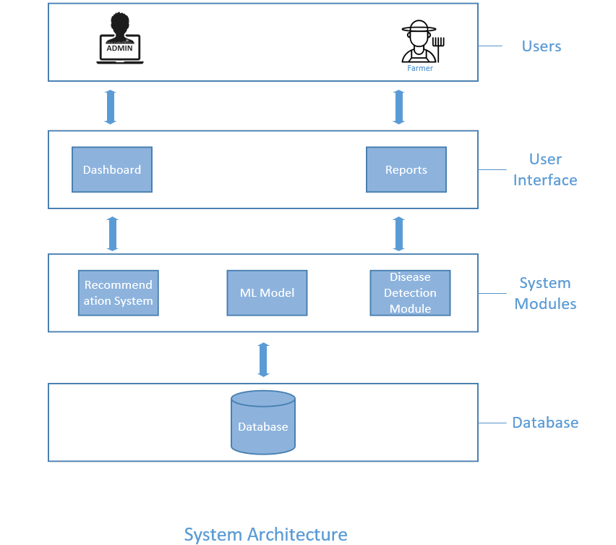
7.2 Data Flow Diagrams
Level 0 DFD
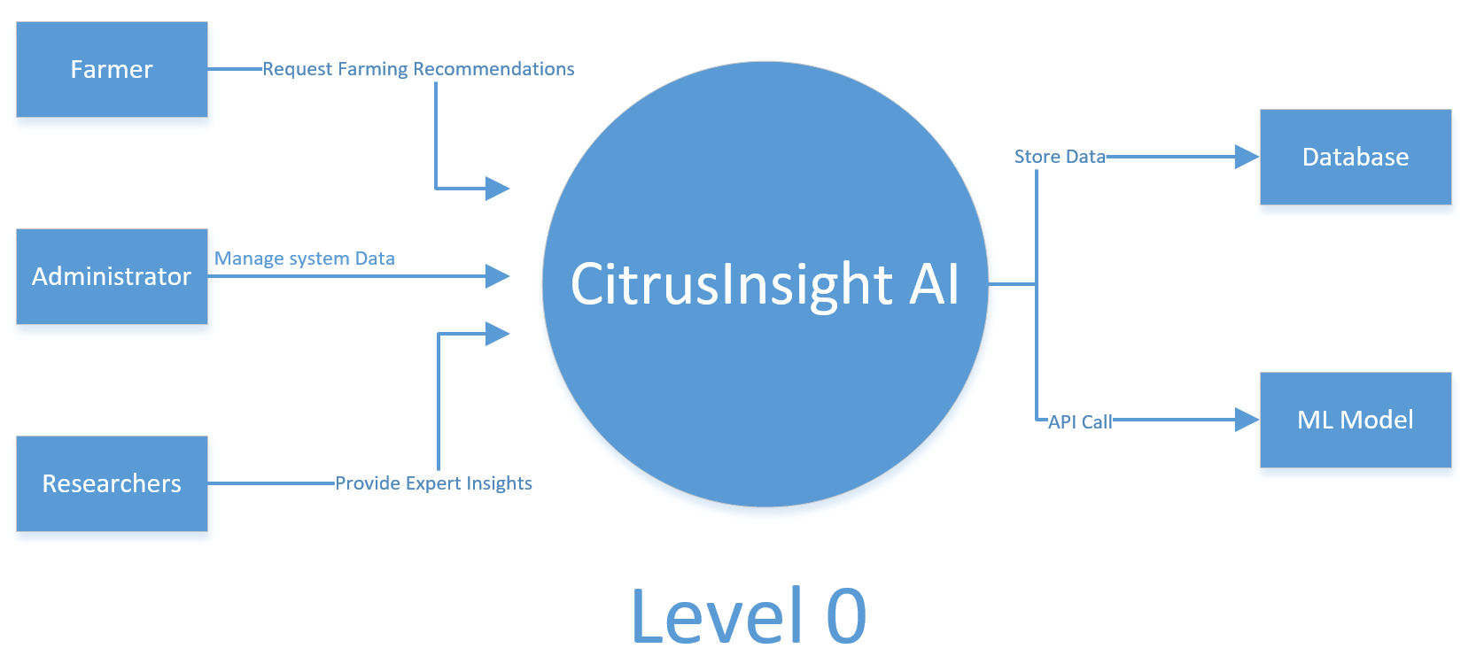

Level 1 DFD
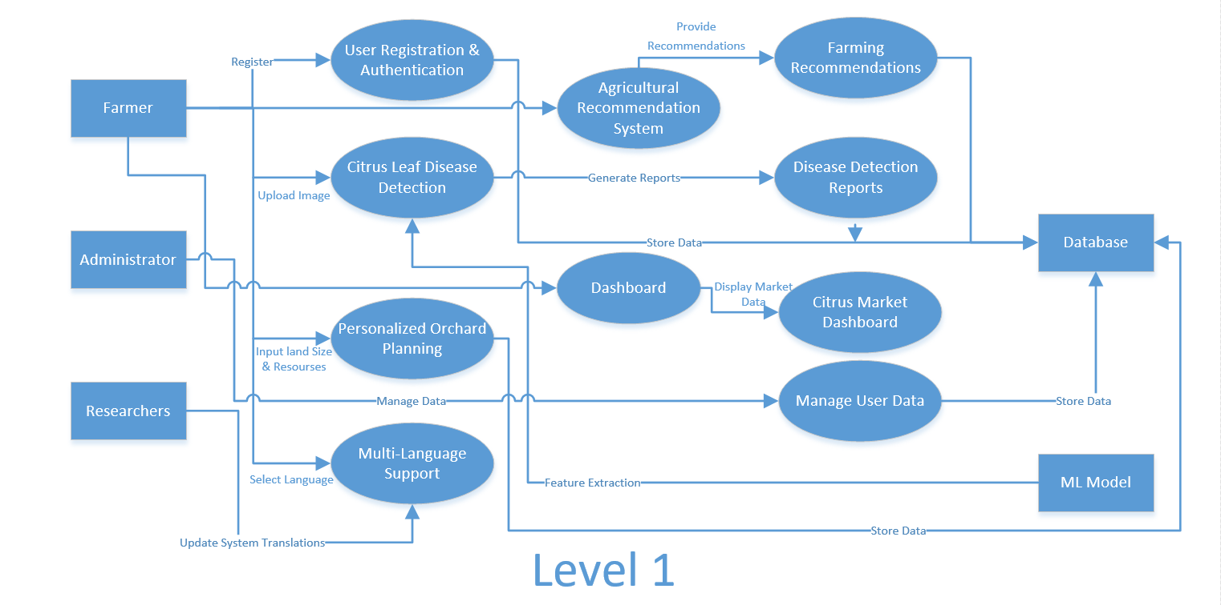

Level 2 DFD
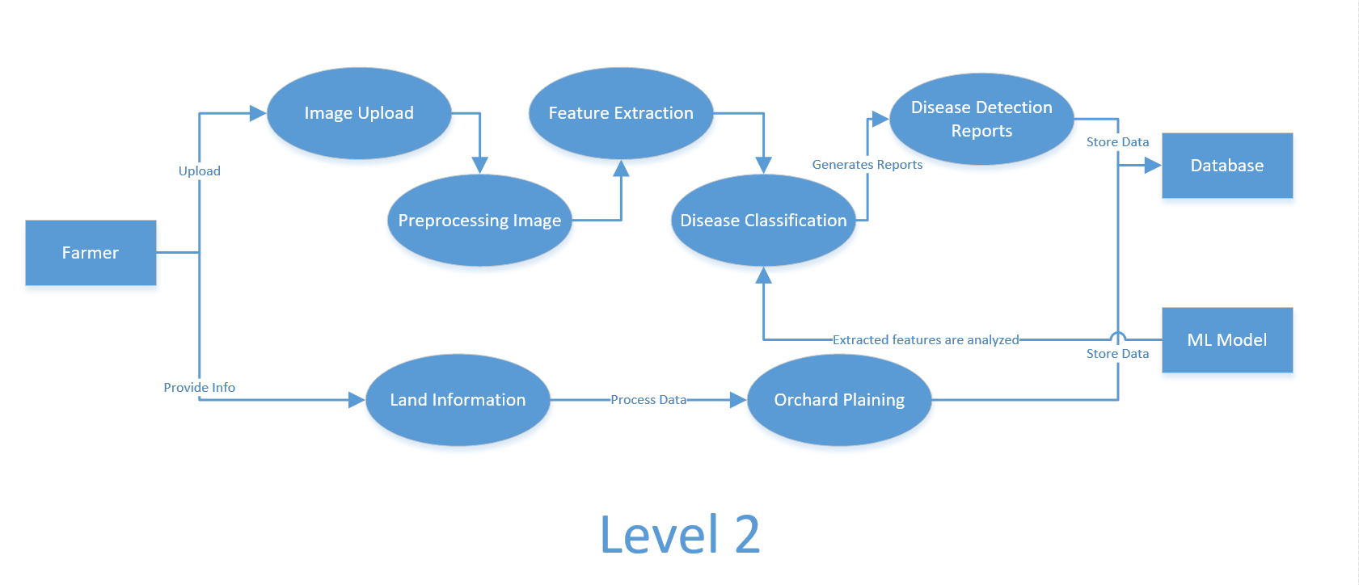

Use Cases

  - Use Case Diagrams
This below is the Use Case of the CitrusInsght AI.

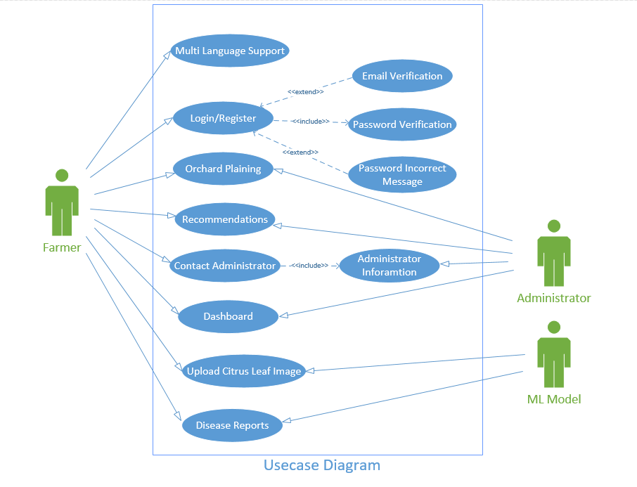

  - Use Case Description
The following are the Use Case description of each Use Case of the CitrusInsight AI.

- Use Case 1

Select Preferred Language
Actors: Farmer
Feature: Farmers are able to choose preferred language for convenience.
Use case Id: |  | UC-01
Pre-condition: |  | The user should be logged into the system.
Scenarios
Step# | Action |  |  | Software Reaction
1. | The farmer chooses a preferred language from options. |  |  | The system refreshes the interface in the chosen language.
Alternate Scenarios:
1a: If the chosen language is not available, the system informs the user and reverts to English.
Post Conditions
Step# | Description
1. | The system makes all subsequent interactions appear in the chosen language.
Use Case Cross referenced |  |  | View Recommendations (UC-08)
User Interface reference |  |  | Select Preferred Language (UI-01)

2. Use Case 2

Register User
Actors: Farmer
Feature: Allows access system features securely.
Use case Id: |  | UC-02
Pre-condition: |  | The user should offer valid credentials.
Scenarios
Step# | Action |  |  | Software Reaction
1. | The user enter name, username, email and password for registration. |  |  | The system checks their right format and register the user.
Alternate Scenarios:
1a: If registration is unsuccessful due to invalid format, the system shows an error message.
Post Conditions
Step# | Description
 | The user is able to access the dashboard.
Use Case Cross referenced |  |  | Authenticate User (UC-03)
User Interface reference |  |  | Register User (UI-02)

3. Use Case 3

Authenticate User
Actors: Farmer
Feature: Allows access system features securely.
Use case Id: |  | UC-03
Pre-condition: |  | The user should offer valid credentials.
Scenarios
Step# | Action |  |  | Software Reaction
1. | The user submits email and password for login. |  |  | The system validates credentials and allows access.
Alternate Scenarios:
1a: If login is unsuccessful due to invalid credentials, the system shows an error message.
2a: When the email is not verified, the system asks the user to verify the email.
Post Conditions
Step# | Description
 | The user is able to access the dashboard.
Use Case Cross referenced |  |  | Register User (UC-02)
User Interface reference |  |  | Authenticate User (UI-03)
4. Use Case 4

Disease Detection
Actors: User, ML Model
Feature: Enables farmers to upload citrus leaf images for disease detection.
Use case Id: |  | UC-04
Pre-condition: |  | The user should be logged in and have an image of the citrus leaf.
Scenarios
Step# | Action |  |  | Software Reaction
1. | The farmer uploads an image of a citrus leaf. |  |  | The system processes the image and passes it through the ML model.
2. | The system provides feedback on whether the leaf is infected by any disease or not. |  |  | The user is presented with the diagnosis and advice.
Alternate Scenarios:
1a: If the file uploaded is not an image, the system requests uploading in a proper format.
2a: If the disease is undetectable to the ML model, the system recommends manual detection.
Post Conditions
Step# | Description
1. | The user gets disease diagnosis and advice.
Use Case Cross referenced |  |  | Generate Disease Report (UC-05)
User Interface reference |  |  | Disease Detection (UI-04)

5. Use Case 5

Generate Disease Report
Actors: Farmer, Administrator
Feature: Provides reports based on uploaded images and identified diseases.
Use case Id: |  | UC-05
Pre-condition: |  | A minimum of one image should have been uploaded for analysis.
Scenarios
Step# | Action |  |  | Software Reaction
1. | User upload image for a disease report. |  |  | System fetches stored images and their diagnosis.
2. | The report is viewed. |  |  | The user views the report.
Alternate Scenarios:
1a: In the absence of any data, the system notifies the user that there are no reports to be created.

Post Conditions
Step# | Description
 | The farmer is provided with a summary of the diseases identified.
Use Case Cross referenced |  |  | Disease Detection (UC-04)
User Interface reference |  |  | Disease Report (UI-05)

6. Use Case 6

Plan Orchard
Actors: Farmer
Feature: Farm Management
Use case Id: |  | UC-06
Pre-condition: |  | The user is logged in.
Scenarios
Step# | Action |  |  | Software Reaction
1. | The user enters information regarding the farm (size, type of crop, etc.). |  |  | The system creates a plan.
Alternate Scenarios:
1a: The user provides incomplete information. The system requests missing information.

Post Conditions
Step# | Description
 | The user is presented with a planning recommendation.
Use Case Cross referenced |  |  | View Recommendations (UC-08)
User Interface reference |  |  | Plan Orchard (UI-06)

7. Use Case 7

View Citrus Dashboard
Actors: User (e.g., researcher, government official, agriculturist)
Feature: View Citrus Production & Trade Dashboard
Use case Id: |  | UC-07
Pre-condition: |  | User accesses the dashboard module.
Scenarios
Step# | Action |  |  | Software Reaction
1. | User navigates to the dashboard section. |  |  | The system navigates to dashboard.
2. | System fetches and displays the selected data using charts/tables/maps. |  |  | The system display the desired dashboard.
Alternate Scenarios: If data is missing for a selected filter, system shows "No Data Available."
Post Conditions
Step# | Description
 | Dashboard displays relevant insights and visualizations.
Use Case Cross referenced |  |  | N/A
User Interface reference |  |  | View Citrus Dashboard (UI-07)

8. Use Case 8

View Recommendations
Actors: User (e.g., researcher, government official, agriculturist)
Feature: View Monthly Recommendations
Use case Id: |  | UC-08
Pre-condition: |  | User must have access to recommendation system
Scenarios
Step# | Action |  |  | Software Reaction
1. | User navigates to the recommendation system. |  |  | The system navigates to recommendation system.
2. | System fetches and displays the selected data. |  |  | The system displays the desired recommendation system.
Post Conditions
Step# | Description
 | Recommendation system displays the recommendations.
Use Case Cross referenced |  |  | Plan Orchard (UC-06)
User Interface reference |  |  | View Recommendations (UI-08)

Graphical User Interfaces
The following are the User Interfaces of the CitrusInsight AI.
  - Graphical User Interface 1

Select Preferred Language
Interface Id. | UI-01
Use case Reference | Select Preferred Language
Snapshot
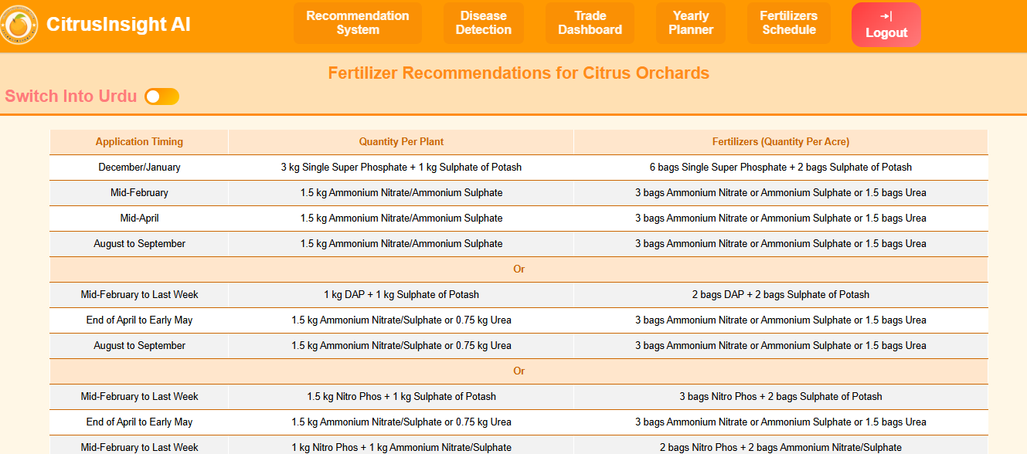

  - Graphical User Interface 2

Register User
Interface Id. |  | UI-02
Use case Reference |  | Register User
Snapshot
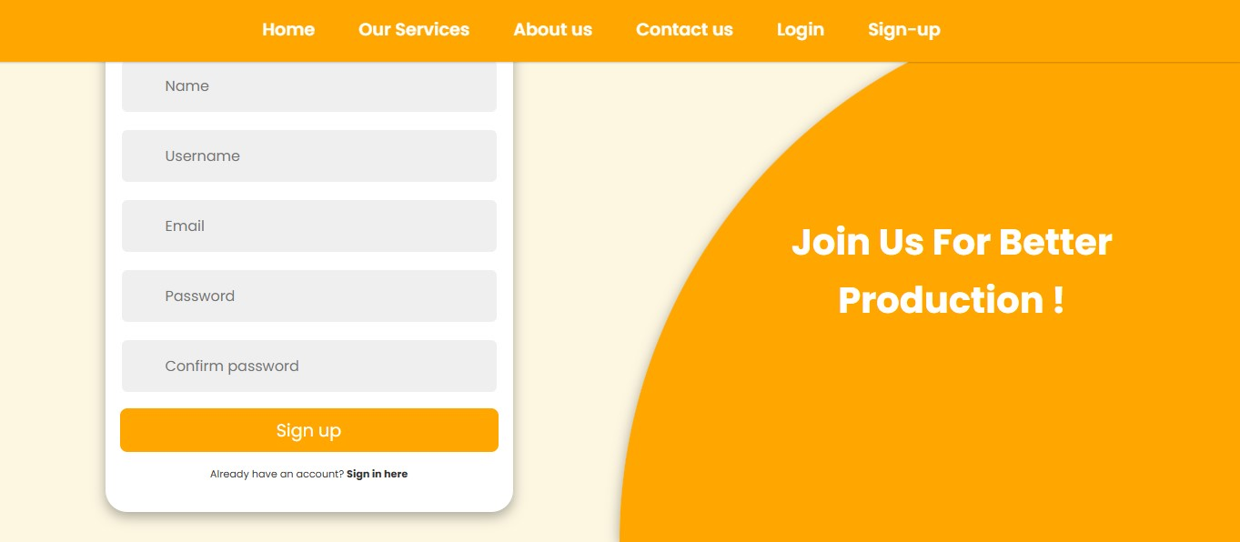
Data dictionary reference
Label | Data dictionary identifier
Email | email
Password | password
Name | name
Username | username

  - Graphical User Interface 3

Authenticate User
Interface Id. |  | UI-03
Use case Reference |  | Authenticate User
Snapshot
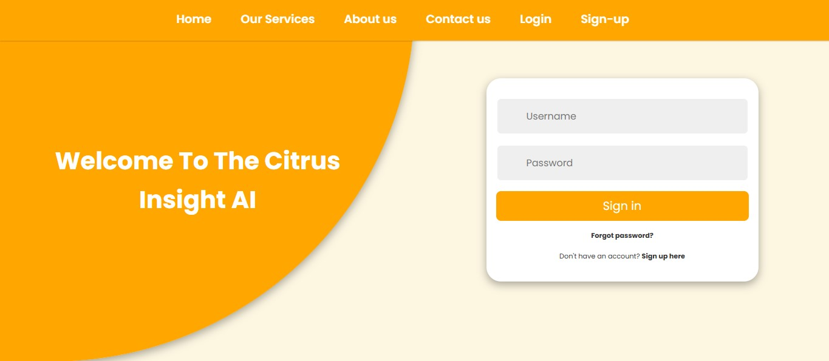
Data dictionary reference
Label | Data dictionary identifier
Email | email
Password | password

  - Graphical User Interface 4

Disease Detection
Interface Id. |  | UI-04
Use case Reference |  | Disease Detection
Snapshot
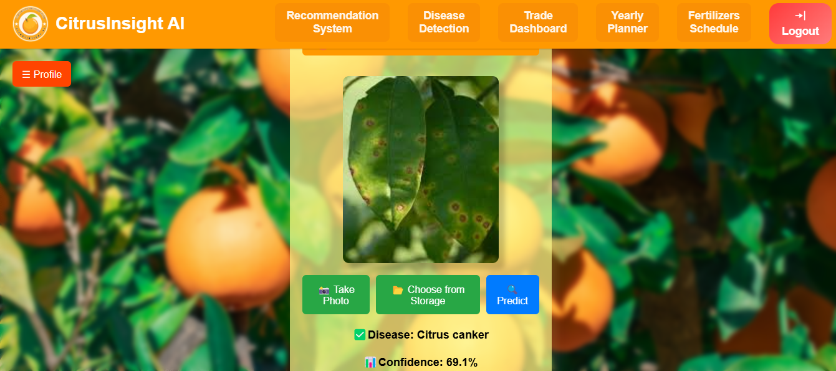
Data dictionary reference
Label | Data dictionary identifier
Disease Result | disease_result
Confidence Score | confidence_score

  - Graphical User Interface 5

Disease Report
Interface Id. |  | UI-05
Use case Reference |  | Generate Disease Reports
Snapshot
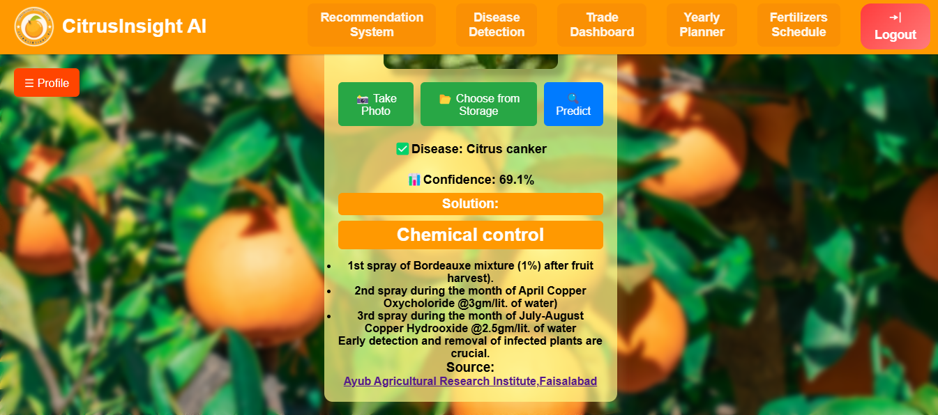

Data dictionary reference
Label | Data dictionary identifier
Report ID | report_id
Prediction Result | Prediction_result
Confidence Score | Confidence_result

  - Graphical User Interface 6

Plan Orchard
Interface Id. |  | UI-06
Use case Reference |  | Plan Orchard
Snapshot
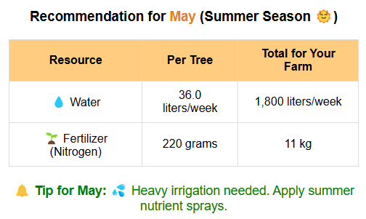
Data dictionary reference
Label | Data dictionary identifier
Farm Size | Farm_size
Plant Count | Plant_count
Citrus Type | Citrus_type

  - Graphical User Interface 7

View Citrus Dashboard
Interface Id. |  | UI-07
Use case Reference |  | View Citrus Dashboard
Snapshot
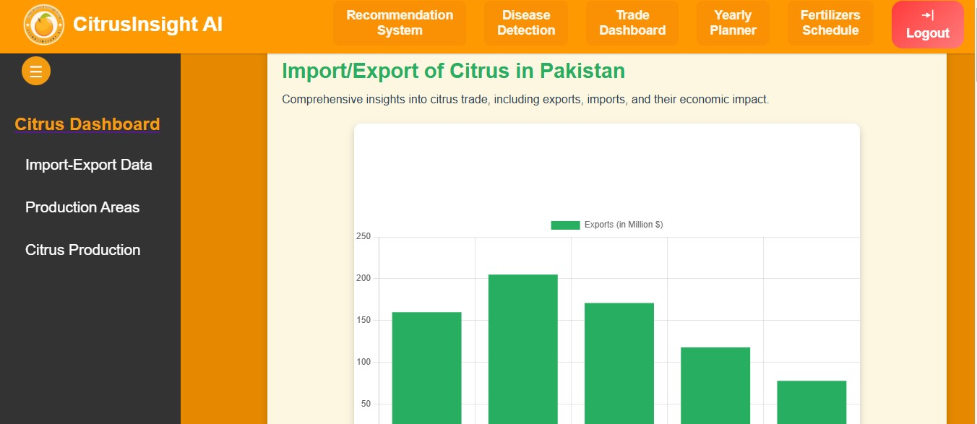

Data dictionary reference
Label | Data dictionary identifier
User Email | email
User Password | password

  - Graphical User Interface 8

View Recommendations
Interface Id. |  | UI-08
Use case Reference |  | View Recommendations
Snapshot
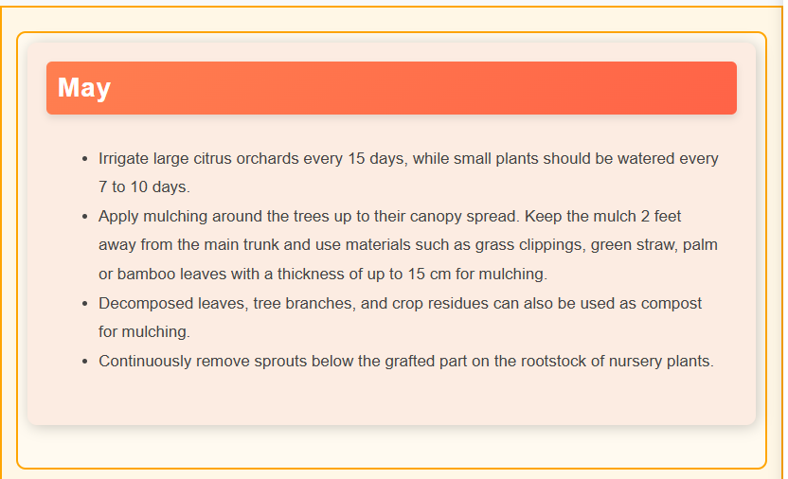

Data dictionary reference
Label | Data dictionary identifier
Recommendation Text | Recommendation_text

High Level Design

  - ER Diagram
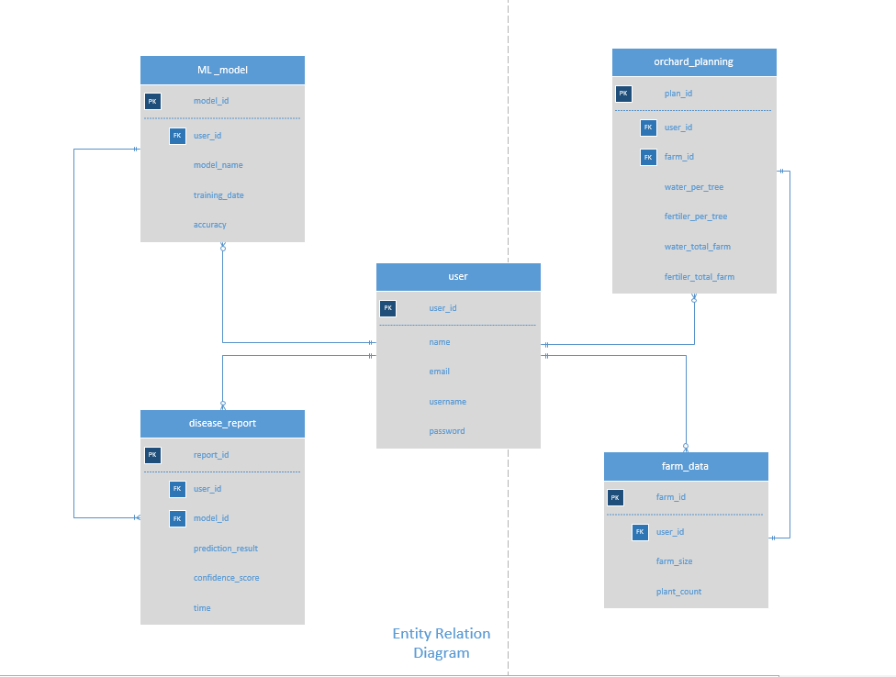
  - Data Dictionary
The following are Data Dictionaries of the CitrusInsight AI.

    - Data 1

User
Name | User
Alias | Account, Member
Where-used/how-used | - Used in authentication, registration, and login.  - Referenced by Disease Reports, Image Uploads, Recommendations, and Orchard Planning.  - Stores user information such as Name, Email, and Password.
Content description | Stores user information like name, email, username and password
Supplementary information | Password is stored encrypted.

    - Data 2

Disease Report
Name | Disease Report
Alias | Health Report, Citrus Diagnosis
Where-used/how-used | - Used when a user uploads an image to detect disease.  - Referenced by ML Model for prediction.  - Generates PredictionResult with ConfidenceScore and ReportDate.
Content description | Stores results of disease name, confidence, and report generation date.
Supplementary information | For tracking past disease reports for analysis.

    - Data 3

Image Upload
Name | Image Upload
Alias | Citrus Image, Leaf Image Upload
Where-used/how-used | - User uploads images for disease detection.  - Linked to Disease Report for prediction processing.  - Stores image URLs and upload times.
Content description | uploaded images by users.
Supplementary information | System supports multiple image formats (JPG, PNG).

.
    - Data 4

Recommendation
Name | Recommendation
Alias | System Advice
Where-used/how-used | - Created on the basis of Disease Report.  - Gives users suggestions on how to treat detected diseases.  - References User and ReportID.
Content description | Saves system-generated suggestions based on months.

    - Data 5

Farm Data
Name | Orchard Planning
Alias | Plantation Management, Yield Estimation
Where-used/how-used | - Assists users in planning citrus plantation and yield estimation.  - Referenced by User for ownership tracking.  - Saves EstimatedYield and PlantationDate.
Content description | Stores user's farm data like farm size, not of plants, avergeae.
Supplementary information | Data can be used to maximize plantation schedule.

    - Data 6

ML Model
Name | ML Model
Alias | AI System, Citrus Disease Detection Model
Where-used/how-used | - Trained model to detect citrus leaf diseases.  - Consumed by Disease Report to forecast results.  - Stores model metadata such as TrainingDate and Accuracy.
Content description | Stores machine learning model details for disease detection.
Supplementary information | Model updates can increase accuracy over time.

The notation to develop content description is given below:

Data construct | Notation | Meaning
 | = | is composed of
Sequence | + | and
Selection | [|] | either-or
Repetition | {}^{n} | n repetitions of
 | ( ) | optional data
 | * … * | delimits comments

Requirements Traceability Matrix

Sr. # | Feature | Use case ID | UI ID | Priority | Build Number | Use Case Cross reference  (Related Use Cases)
01 | Multi language support | UC-01 | UI01 | Low | Build 1 | UC08
02 | Register User | UC02 | UI02 | Medium | Build 1 | UC01
03 | Authenticate User | UC03 | UI03 | High | Build 2 | UC02
04 | Disease Detection | UC04 | UI04 | High | Build 1 | UC05
05 | Generate Disease Report | UC05 | UI05 | Medium | Build 3 | UC04
06 | Plan Orchard | UC06 | UI06 | High | Build 2 | UC07
07 | View Citrus Dashboard | UC07 | UI07 | Medium | Build 3 | N/A
08 | View Recommendations | UC08 | UI08 | Medium | Build 3 | UC06

The columns carry the following meaning:

- Feature: Lists system features based on which use cases are built.
- Use Case ID: Write the ID of the use case for easy lookup
- UI ID: Write the user interface ID for this use case.
- Priority: Give an appropriate rating to each use case according to its priority
- Build Number: Write the reference number to which this feature belongs.
- Use Case Cross Ref: Write the related use cases separated with commas.

Risk Analysis

Risk Driver | Description | Estimated Impact (%)
Incomplete or inconsistent datasets | May prevent training of effective ML models for disease detection | 25%
Limited access to expert validation | May impact month-wise recommendations reliability | 20%
Internet and server downtime | Affects web platform availability for farmers | 15%
Skill limitations in ML/web integration | May slow down development and decrease system quality | 20%
Low adoption by farmers | Due to language issues or new tech resistance | 20%

Risk Mitigation Plan
- Leverage public agricultural datasets and collaborate with local research centers for expert-checked data.
- Provide regular backup and utilize robust hosting for maximum uptime.
- Split the team according to skill sets to cater to web development, data science, and testing.
- Perform pilot testing on actual farmers and localize the platform in Urdu or regional dialects.
- Regularly take inputs from end-users and continuously improve based on usability and trust.

Cost Estimation Sheet

Sr | Cost Category | Explanation | Estimated Cost
 | Software development cost | 3 members * 6 months at 40,000 per month | Rs: 974000/-
 | Packaged software | Hugging face space , sql server, Hosting and domain | Rs: 15,000/-
 | Hardware | 3 laptops core I 5 8 gb Ram | Rs: 1,50,000
 | Network | 10mbps internet bill for six month | Rs: 12,000/-
 | Client | N/A | N/A
 | Misc. | Electricity, travel fairs etc. | Rs: 5,000/-
7. | Testing
 |  |  | Total cost = Rs:1,156,000/-

Estimating Cost using COCOMO Model:

Project category: Organic
Effort Equation: E = 2.4 × (KLOC)^1.05
Development Time: D = 2.5 × (E)^0.38

Code Size Conversion (KLOC)
Total LOC=2000
KLOC=2000/1000=2.0 KLOC

Effort Estimation (Person-Months)
E=2.4×(2.0)^1.05 ≈ 4.97 person-months

Development Time (Months)
D=2.5×(4.97)^0.38 ≈4.6 months

People Required
P=E/D=4.97/4.6​≈1.08

Cost Estimation:

Effort = 4.97 person-months
Assumed Monthly Salary = $700/month
Total Cost=4.97×700=3480USD ≈ 974000 PKR

References

  - Kukreja, Vinay, and Poonam Dhiman. "A Deep Neural Network based disease detection scheme for Citrus fruits." 2020 International conference on smart electronics and communication (ICOSEC). IEEE, 2020.
  - Syed-Ab-Rahman, Sharifah Farhana, Mohammad Hesam Hesamian, and Mukesh Prasad. "Citrus disease detection and classification using end-to-end anchor-based deep learning model." Applied Intelligence 52.1 (2022): 927-938.
  - Çetiner, Halit. "Citrus disease detection and classification using based on convolution deep neural network." Microprocessors and Microsystems 95 (2022): 104687.
  - Emon, Yousuf Rayhan; Ahad, Md Taimur (2023), “Multi-format open-source sweet orange leaf dataset for disease detection, classification, and analysis.”, Mendeley Data, V1, doi: 10.17632/f7cr74mwpj.1

